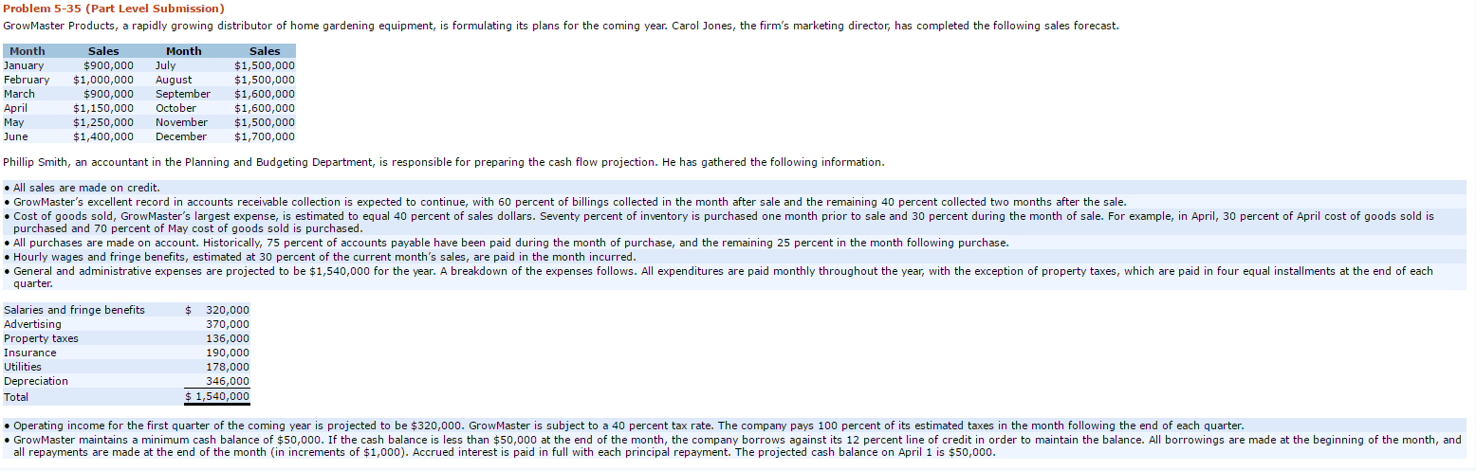
- PLEASE ANSWER QUESTION BELOW
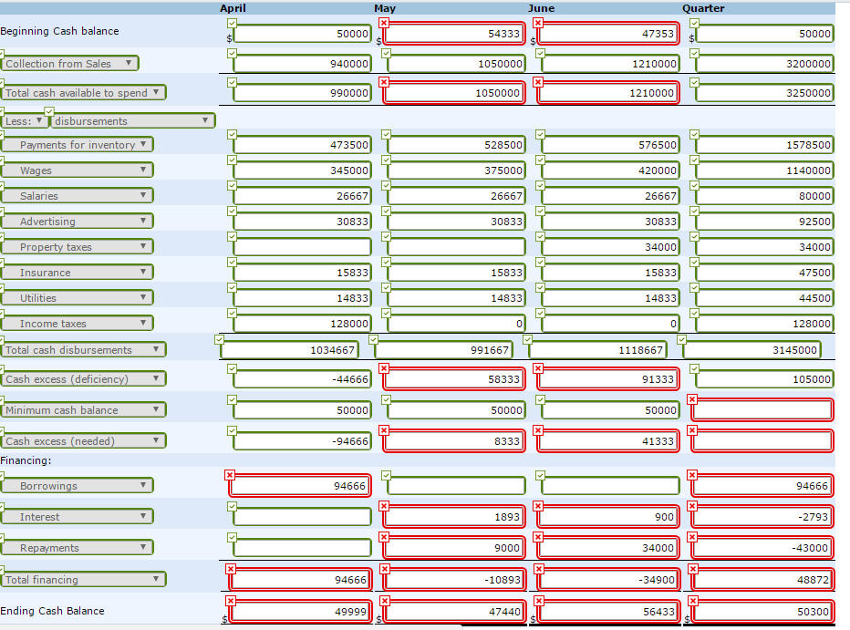
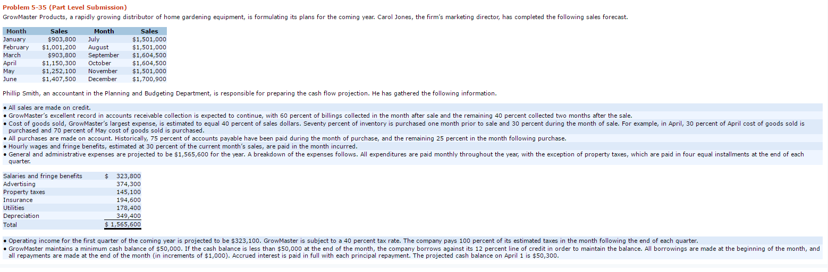
2. PLEASE ANSWER QUESTION BELOW

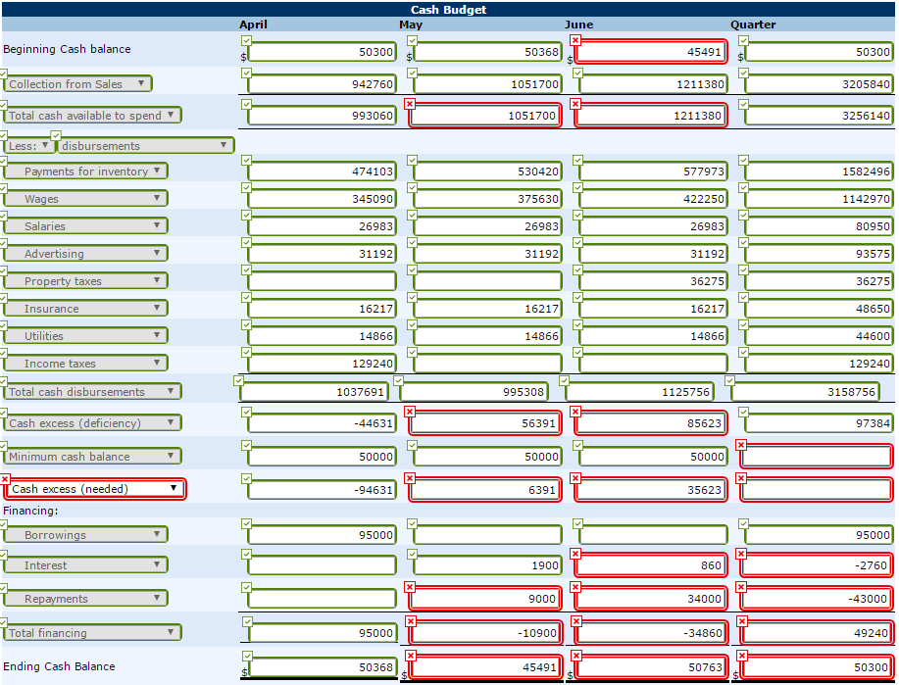
3. PLEASE ANSWER QUESTION BELOW
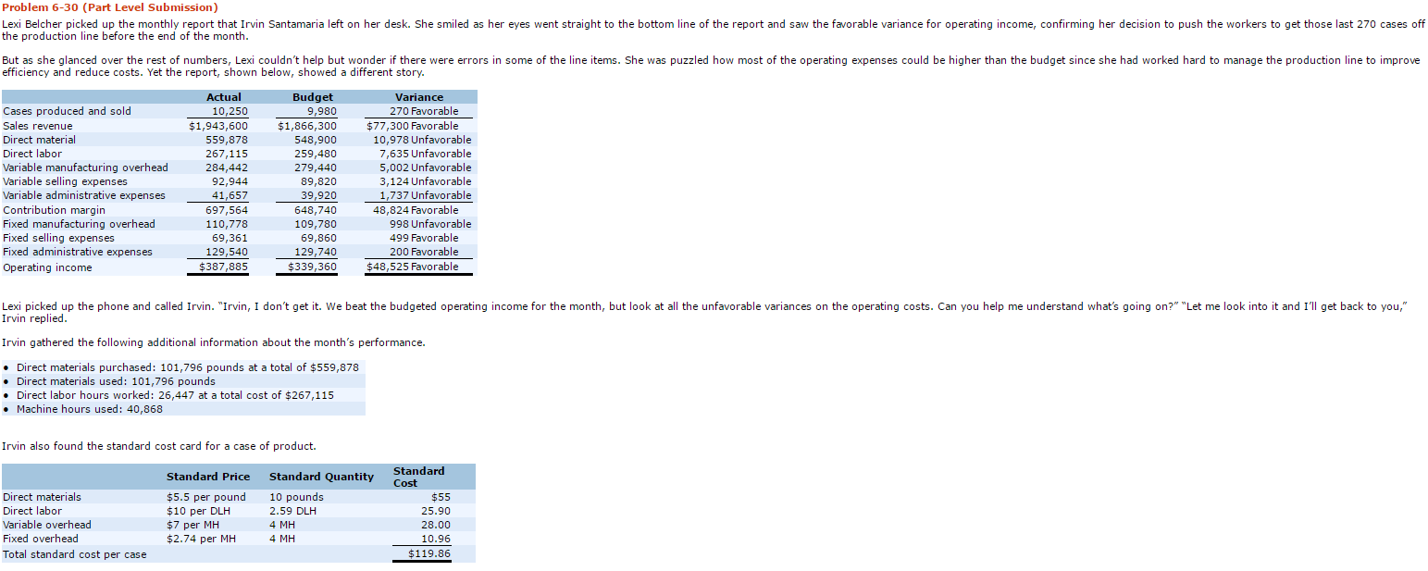
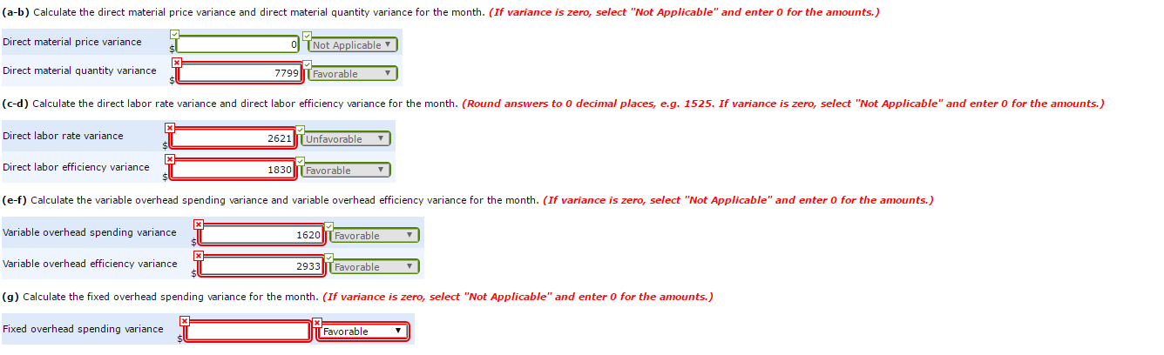

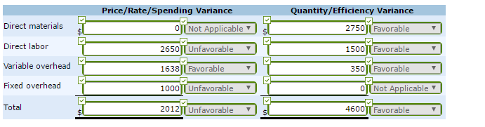
4. PLEASE ANSWER QUESTION BELOW
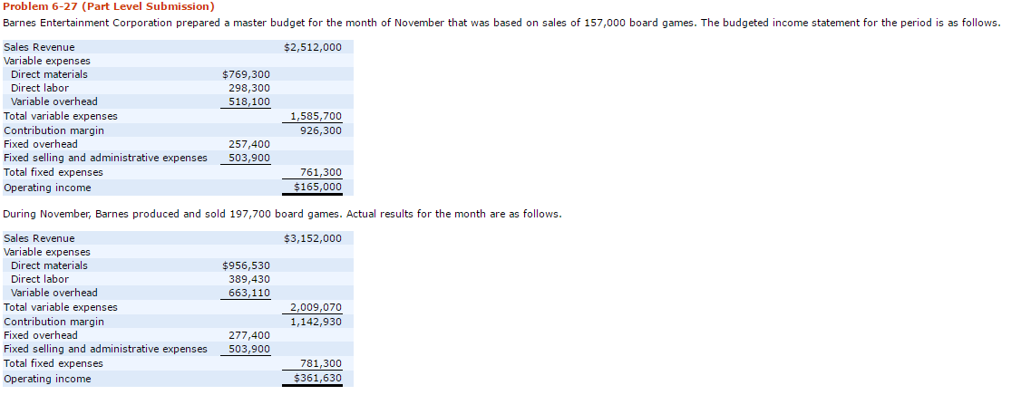
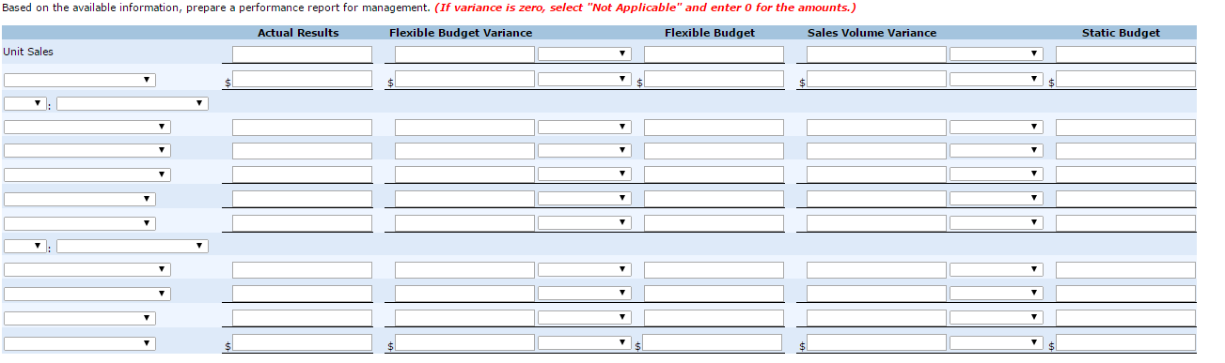
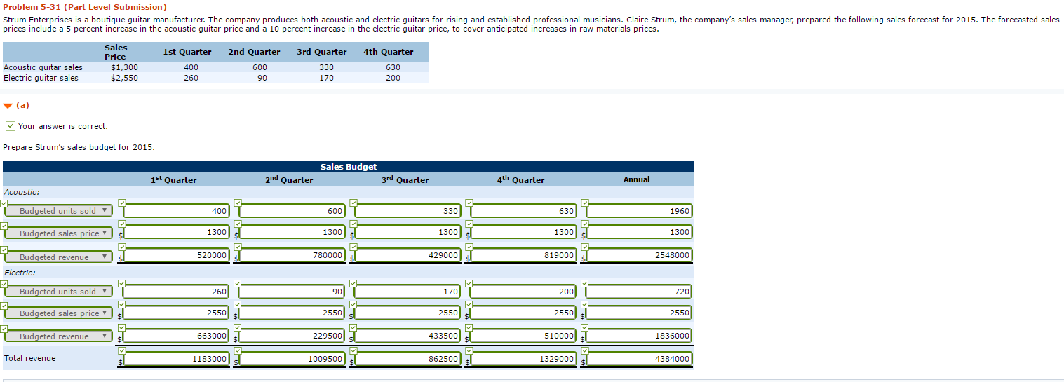
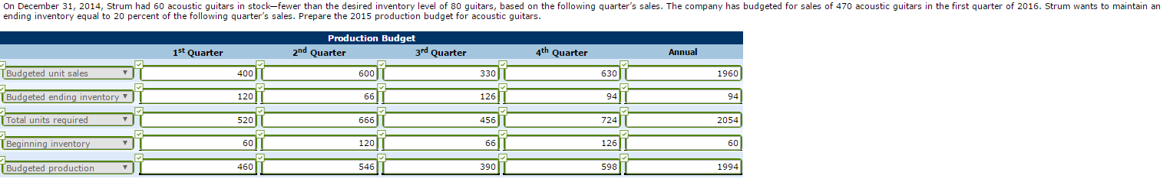
5. PLEASE ANSWER QUESTION BELOW
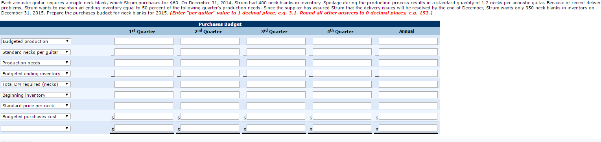

6. PLEASE ANSWER QUESTION BELOW
